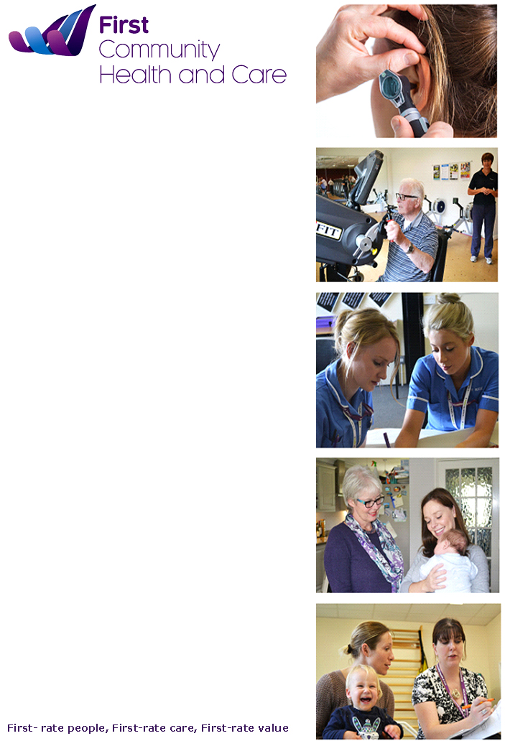***Contents***

**Equality Diversity and Human Rights Annual Report 2017/2018**

**Prepared by**

**Tina Gull**

**Equality Consultant**

**April 2018**

|  |  |
| --- | --- |
| **Title** | **Page** |
| ***Executive Summary*** | ***3*** |
| ***Introduction*** | ***5*** |
| ***Our Commitment to Equality Diversity and Human Rights*** | ***7*** |
| ***The Legislation/Equality Duty*** | ***7*** |
| ***Equality Leadership*** | ***8*** |
| ***Our Population*** | ***9*** |
| ***FCHC Workforce 2018*** | ***15*** |
| ***Gender Pay Reporting*** | ***21*** |
| ***Patient Information*** | ***23*** |
| ***Public and Patient Involvement*** | ***26*** |
| ***Staff Engagement*** | ***28*** |
| ***NHS Staff Survey Results*** | ***29*** |
| ***Workforce Race Equality Standard (WRES)*** | ***30*** |
| ***Carers Strategy 2015-2018*** | ***30*** |
| ***Company Strategy 2017-2020*** | ***31*** |
| ***Equality Analysis*** | **31** |
| ***Equality Delivery System (EDS2)*** | **31** |
| ***Equality Objectives 2015-2019*** | **32** |
| ***Complaints*** | **34** |
| ***Accessible Information Standard (AIS)*** | **35** |
| ***Equality, Diversity and Human Rights training*** | **36** |
| ***Priorities for the next 12 months*** | **37** |
| ***Appendix 1 Accessible Information Standard data*** | **38** |
| ***Appendix 2 WRES Action Plan*** | **39** |

***Executive Summary***

***Key Points***

* Although the population in Surrey is predominately White British the population is becoming more diverse in both Surrey and Sussex. In East Surrey 8.3% of the population are of non-white ethnic backgrounds compared to 14.6% for England. Almost 2.24% of the population describe themselves as other Asian and are likely to be Nepalese, while 1.39% of the local population describes themselves as Indian, followed by 1.31% Black African Caribbean and 0.62% Pakistani. Crawley’s largest non-white populations are Polish, Indian, Sri Lankan and Pakistani.
* The Equality Act 2010 requires organisations to collect equality information on both staff and patients. This information helps us understand the effect on equality of our current and proposed policies, practices and decisions, identify what the key priority equality issues are for the organisation, set the most appropriate equality objectives and measure progress against them. Having this information can help us to identify barriers and discrepancies between groups so we can plan remedial action, it can tell us where we are making progress on equality and where action is most needed. It will also help us to understand our workforce and enables us to review how representative we are of our local population. There has been little change to the demographics of our workforce regarding Age, Gender. Religion and Belief, Marital Status or Ethnicity however the percentage of staff who have not disclosed their ethnicity has reduced again this year to 13.3% following the data validation exercise.
* There have been 4 employee relations cases again this year which is very small (in the previous two years there were also 4 ER cases each year) so it is difficult to draw conclusions. However there are consistently 50% of ER cases involving BME staff which is disproportionate to the number of BME in the organisation therefore we will continue to triangulate this information with our other WRES data and agree actions to take forward.
* We collect equality and diversity data on our patients to help us to understand more about the people who are accessing our services and to understand what we need to do to make sure our services are accessible to everyone and meet the needs of our patients. To help us to do this we need to gather as much information as we can. The data shows that there is further work to be done to improve the recording of patient data particularly with regard to ethnicity where 43% of patients are recorded as ethnicity unknown, marital status 57% of patients have marital status unknown, and religion and belief where 75% of patients with religion and belief as unknown.
* Over the last two years we have seen an improvement in the recording and reporting of patient ethnicity and during 2016/2017 this had improved slightly to 64.8% of patients where we have a record of their ethnicity. However this year we have 43% of patients where this is unknown and this is an area that we are working on to improve the capture of patient data.
* We have continued to develop the Community forum during the year providing us with an on-going way to engage with, listen to and involve organisations and people in the communities where First Community provides services. We were involved in developing a range of ‘prototypes’ over the year to test new ideas across a range of local health and social care needs. These were social isolation, diabetes, falls prevention, a good death and physical health of people with severe mental illness. In developing each of these prototypes, we worked with patients and service users, as well as health and social care specialists, to trial and test out new ways of working.
* We developed our staff engagement opportunities during the year, our aim I to encourage staff to engage with and shape the direction of First Community. A range of group sessions were held by the CEO to hear the views of colleagues to set First Community’s three year strategy which will set our direction for the next three years. Annual awards enable us to recognise excellence by individuals and teams, and a series of focus groups looked at three areas following the 2016 staff survey. Health and wellbeing of staff, corporate resources and reward and recognition. A number of short medium and long term recommendations were implemented and the long-term suggestions are being included within strategies. Among the actions implemented were: parking permits, Walking Wednesdays, no meetings over lunchtimes and YMCA health assessments.
* The NHS staff survey results for a second year looked at employee satisfaction. The overall results were positive with colleagues across First Community continuing to rate its care highly, remain highly engaged and say it’s a good place to work. The results showed staff engagement increased to 4.08 (out of 5.00) compared to 4.05 in 2016, a score above 4.00 equates to a highly engaged workforce. The results of the 2017 survey showed some significant changes since the 2016 survey, which demonstrated differing experiences of BME (Black and Minority Ethnic) colleagues compared to white colleagues. There was a significant fall in the number of BME colleagues who said they were discriminated against - 16% BME colleagues said they had experienced discrimination at work in 2017 compared to 29% in 2016. While this is a decrease, First Community will continue to explore this and understand what more needs to change.
* Regular reports enable us to review how we are performing against the Accessible Information Standard and provide us with valuable information on how we can assist patients with communication needs. The main ways patients have said they need support are communication via a carer, use of a hearing aid, needing the help of an advocate, or requires information in a larger font size.
* All staff including both substantive and Bank staff - must complete Equality, Diversity training within six months of commencing in the organisation and complete a refresher every three years. A blended approach to training is provided giving staff the option to complete eLearning modules or to attend a face to face session. Reporting indicates a drop in compliance although this has been attributed to reporting issues from LMS and an action plan has been developed to address this.
* We completed our initial Workforce Race Equality Standard (WRES) baseline audit in 2016 and the second in July 2017. The 2017 initial results for First Community suggested variations in experiences between BME and white staff in a number of indicators. An action plan has been produced to tackle these variations. The key actions achieved this year relating to the WRES action plan are;
* Focus groups were held with staff during October/November to discuss the findings of the NHS Staff survey and to help us to understand why BME staff feel they are being treated differently from other staff.
* The BME network has been set up and has met, terms of reference have been agreed.
* A data validation exercise was held in January 2018 to try to improve the staff personal equality data held on the system this has resulted in an improvement of the percentage of staff who have disclosed their ethnicity
* We have begun a Leadership Programme for Managers which will include sessions on HR and Equality Diversity and Inclusion.

***Priorities for the next 12 months:***

* To develop an overarching Equaity, Diversity and Inclusion Group to meet all elements of the equality agenda. Terms of Reference to be developed and the group will report to EMT.
* To update the Equality Delivery System (EDS2) audit tool to help us to develop new equality objectives for the organisation
* To improve the quality of the patient data we collect
* To continue to implement the WRES action plan to help us reduce the variation in experiences between BME and white staff
* To prepare for the introduction of the Workforce Disability Equality Standard

***Introduction***

First Community Health and Care delivers front-line NHS services, providing first-rate care, through our first-rate people, offering first-rate value to our local community.

We are a community interest company.  Any surplus we make is reinvested into community services. We play a vital role in our local health community, which we believe is essential to ensure local people have good, prompt access and first-rate care.

In August 2017 CQC rated First Community as outstanding following its inspection of our services in March 2017.

*We will provide:*

***First-rate care***

*We are trained and knowledgeable professionals committed to providing seamless high quality, timely and safe care without boundaries. We are empathetic to the needs of service users, their families and carers, celebrating patient choice.*

***First-rate value***

*We are efficient and effective in our business, continually learning and improving, and are intellectually curious. We deliver value for money, bespoke care, focused on the health of the service user. We offer value back into the community, leaving a social impact locally.*

***First-rate people***

*We are caring, conscientious, compassionate and approachable people, supported to develop our potential. We are respectful and listen, to understand what is important to others. We are effective at communicating with confidence and authenticity. We are flexible and adaptable to our community and its requirements of health care services.*

***Vision***

*Rejuvenating the wellbeing of our community.*

We currently employ 534 permanent staff and provide NHS healthcare services free at the point of care to a population of over 180,000 in East Surrey and the surrounding areas. Our services include community and specialist rehabilitation and therapies, Caterham Dene Community Hospital which also has an inpatient ward, minor injuries unit and rapid assessment and treatment clinic. Health visiting, school nursing, immunisation and children therapies services.

## Our Commitment to Equality, Diversity and Human Rights

As a healthcare provider, an employer and a social enterprise we are committed to ensuring that equality, diversity and human rights are at the heart of what we do and the way we work. This means that we undertake to act fairly and equitably at all times, towards our patients and service users, their families and carers and our staff.

## The Legislation

The Equality Act 2010 is the legislative framework that protects individuals from unfair treatment and promotes a fair and more equal society. The Act strengthened the law on discrimination and replaces the public sector duties for Race, Disability and Gender with the Public Sector Equality Duty which extends to people who fall into groups which have one or more of the following nine protected characteristics;

* Age
* Disability
* Gender reassignment
* Marriage and Civil Partnership
* Pregnancy and Maternity
* Race
* Religion and belief
* Sex
* Sexual Orientation

## The General Duty

* Eliminate unlawful discrimination, harassment, victimisation, and any other conduct that is prohibited by or under the Act, of people who share a protected characteristic
* Advance equality of opportunity between people who share a protected characteristic and persons who do not
* Foster good relations between people who share a protected characteristic and persons who do not

These are sometimes referred to as the three aims or arms of the general equality duty, having due regard for advancing equality involves:

* Removing or minimising disadvantages suffered by people due to their protected characteristics.
* Taking steps to meet the needs of people from protected groups where these are different from the needs of other people.
* Encouraging people from protected groups to participate in public life or in other activities where their participation is disproportionately low.

As part of our public duty we are required to take steps to understand the impact on equality of our policies, practices and the decisions we take for service users and staff and to publicise this information and to report on this annually as part of an annual Equality and Diversity report. This is our fourth Equality and Diversity Annual Report.

## *Equality Leadership*

Meeting our responsibilities with regards equality, diversity and human rights is an integral part of the leadership role at First Community Health and Care. Overall responsibility rests with our leadership team, headed by the Chief Executive and the Chief Nurse and Director of Clinical Standards.

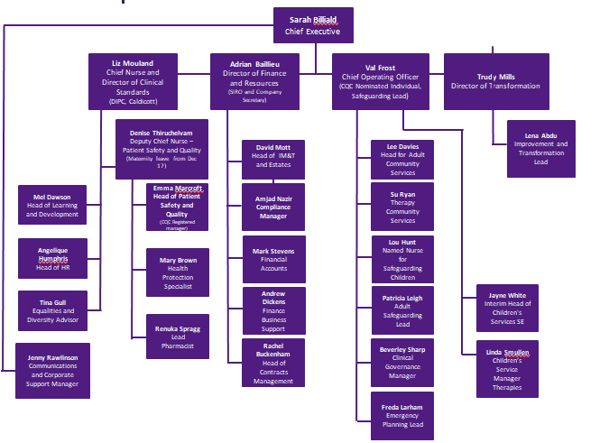

***Our Population***

***Reigate and Banstead***

**Population:** 144,000. The health of people in Reigate and Banstead is generally better than the England average. Reigate and Banstead is one of the 20% least deprived districts/unitary authorities in England, however about 11% (2,800) of children live in low income families. Life expectancy for both men and women is higher than the England average.

**Health inequalities** - Life expectancy is 7.1 years lower for men and 4.4 years lower for women in the most deprived areas of Reigate and Banstead than in the least deprived areas in the borough.

**Child health** In Year 6, 13.4% (168) of children are classified as obese, better than the average for England. The rate of alcohol-specific hospital stays among those under 18 is 49*. This represents 16 stays per year. Levels of teenage pregnancy, GCSE attainment, breastfeeding initiation and smoking at time of delivery are better than the England average.

**Adult health** The rate of alcohol-related harm hospital stays is 516*, better than the average for England. This represents 712 stays per year. The rate of self-harm hospital stays is 222*, worse than the average for England. This represents 307 stays per year. The rate of people killed and seriously injured on roads is worse than average. The rate of sexually transmitted infections is better than average. Rates of statutory homelessness, violent crime, long term unemployment, early deaths from cardiovascular diseases and early deaths from cancer are better than average. * rate per 100,000 population.

**Local priorities** in Reigate and Banstead include mental health, healthy weight and ageing well (including dementia).

***Tandridge***

**Population**: 86,000. The health of people in Tandridge is generally better than the England average. Tandridge is one of the 20% least deprived districts/unitary authorities in England, however about 11% (1,600) of children live in low income families. Life expectancy for men is higher than the England average.

**Health inequalities** - life expectancy is 3.5 years lower for men and 6.8 years lower for women in the most deprived areas of Tandridge than in the least deprived areas.

**Child health** In Year 6, 14.8% (105) of children are classified as obese, better than the average for England. The rate of alcohol-specific hospital stays among those under 18 is 27*. This represents 5 stays per year. Levels of teenage pregnancy, breastfeeding initiation and smoking at time of delivery are better than the England average.

**Adult health** The rate of alcohol-related harm hospital stays is 522*, better than the average for England. This represents 452 stays per year. The rate of self-harm hospital stays is 194*. This represents 164 stays per year. Estimated levels of adult excess weight are better than the England average. The rate of people killed and seriously injured on roads is worse than average. Rates of sexually transmitted infections and TB are better than average. Rates of violent crime, long term unemployment, early deaths from cardiovascular diseases and early deaths from cancer are better than average. * rate per 100,000 population.

**Local priorities** Priorities in Tandridge include alcohol, mental health, healthy weight and ageing well.

***Crawley***

Population: 111,000. The health of people in Crawley is varied compared with the England average. Deprivation is lower than average, however about 18.0% (4,100) children live in poverty. Life expectancy for men is higher than the England average.

**Health Inequalities** Life expectancy is 9.6 years lower for men and 5.2 years lower for women in the most deprived areas of Crawley than in the least deprived areas.

**Child health** In Year 6, 21.7% (259) of children are classified as obese. The rate of alcohol-specific hospital stays among those under 18 is 35*. This represents 9 stays per year. Levels of GCSE attainment are worse than the England average. Levels of breastfeeding initiation and smoking at time of delivery are better than the England average.

**Adult health** The rate of alcohol-related harm hospital stays is 561*, better than the average for England. This represents 559 stays per year. The rate of self-harm hospital stays is 255*, worse than the average for England. This represents 295 stays per year. Rates of sexually transmitted infections and TB are worse than average. Rates of statutory homelessness and violent crime are worse than average. The rate of long term unemployment is better than average. * rate per 100,000 population.

**Local priorities** in Crawley include dementia, tackling health inequalities and premature mortality, emotional wellbeing, reducing social isolation, alcohol and promoting healthy lifestyles.

Data Source Public Health England Health Profiles 2017

***Ethnicity***

Although the population in Surrey is predominately White British the population is becoming more diverse in both Surrey and Sussex as the census figures of 2011 illustrate.

|  |  |  |  |  |
| --- | --- | --- | --- | --- |
| Local Authority area | White British | White Other | Non White | Total Population |
| Crawley | 72.1% | 7.8% | 20.1% | 109,000 |
| Reigate and Bansted | 85.0% | 5.7% | 9.4% | 143,000 |
| Tandridge | 89.3% | 4.6% | 6.2% | 85,000 |

Data Source: - Census data 2011

In East Surrey 8.3% of the population are of non-white ethnic backgrounds compared to 14.6% for England. Almost 2.24% of the population describe themselves as other Asian and are likely to be Nepalese, while 1.39% of the local population describes themselves as Indian, followed by 1.31% Black African Caribbean and 0.62% Pakistani.

Crawley’s largest non-white populations are Polish, Indian, Sri Lankan and Pakistani.

The 2011 census recorded a figure of 2,261 Gypsies and Travellers in Surrey but it is thought the figure is actually between 10-20,000 as many Gypsies and Travellers did not take part in the census. There are around 386 Gypsy Travellers in East Surrey. Many gypsies are now settled but still consider themselves to be part of the traveller community. There are around 288 Gypsy, Roma, and Travellers residing in 72 pitches across seven sites in East Surrey.

Ethnicity is an important aspect of a demographic profile of the population because the prevalence of some diseases are different in certain ethnic groups, for example there is a much higher prevalence of ischaemic heart disease in South Asian men than men in the general population, and a much higher mortality rate from stroke in Black Caribbean men than in the general population. Accordingly, engaging in screening, early detection, and behaviour change in these high risk populations is important to prevent future ill health and complications. Additionally, service planning should take into account that projected disease prevalence, hospital episodes, and mortality is altered by the ethnic mix of the local population.

Language can be a barrier to the patient communicating their health needs, and to health care providers delivering appropriate healthcare. Accordingly, a robust understanding of language needs in the local population with regard to the provision of interpreters and translations of patient information leaflets can assist commissioners and service providers in delivering quality healthcare to groups that would otherwise be marginalised. First community Health and Care have a contract with Languageline to provide an interpretation service to patients where needed.

During 2017/18 the organisation spent approximately £4,215.07 on translation and interpretation services to assist patients and their families. This is an increase from £3,500 in the previous year. This also includes additional spending due to the Accessible Information Standard.

***Religion and Belief***

People who follow different religions have beliefs which need to be taken into consideration in the commissioning and delivery of health services. For example, modesty in dress while receiving clinical care and being treated by a doctor of the same sex are important in some religions, while care plans and short breaks services for carers may need to take into account aspects of religion such as festivals and holidays. Different religions tend to have different rituals particularly around births and deaths. The main source of information about what religion the local population practice is the 2011 Census. There was a significant increase in the number of people stating they had no religion in the 10 years between the last census and the 2011 Census. About two-thirds of East Surrey CCG's population said that their religion was Christian in the 2011 Census, while a substantial proportion said they had no religion or did not state their religion.

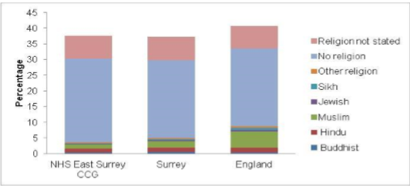

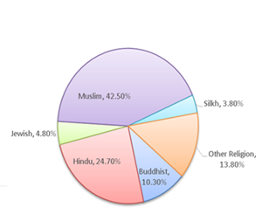

The chart above shows the figures for Non- Christian religions in /west Sussex. Knowing and understanding our patients religion and belief can help us to ensure we are meeting their needs and delivering the best services to them that we can.

Source Census 2011 Note the figures do not include Christians.

Religion and belief is a protected characteristic under the Equality Act (2010), so We must have regard to religious belief in the way in which services are offered. In the main, this will mean having regard for the Christian faith, but consideration also needs to be given to how services are provided for smaller religious groups particularly for those of Muslim, Hindu and Buddhist religions.

***Carers***

Carers look after family partners or friends in need of help because they are ill, frail or have a disability. The care they provide is unpaid.

|  |  |  |  |  |
| --- | --- | --- | --- | --- |
|  | Total Population | Total people all ages providing unpaid care | Total people providing more than 20 hours of care a week | Total people providing more than 50 hours of care a week |
| Surrey | 1,105,800 | 107,829 | 29,364 | 18,397 |
| Reigate and Banstead | 134,346 | 12,980 | 3.656 | 2.257 |
| Tandridge | 80,916 | 8.518 | 2.290 | 1.442 |
| Crawley | 106,597 | 9,902 | 1,418 | 2,106 |

Total numbers of adult carers providing hours of care per week Census data 2011

***Sexual Orientation***

The 2011 census did not include a question on sexual orientation, however it is estimated that there are approximately 78,876 Lesbian, Gay, Bisexual and Transgender (LGBT) people in Surrey. The census did ask how many people were in a civil partnership and results indicate that there are 105,000 people in England and Wales, 2.387 people in Surrey and 1,585 people in West Sussex who are in a civil partnership. There are 201 people in Reigate and Banstead, 232 people in Tandridge and 190 people in Crawley, who have stated they are in a civil partnership. It is estimated that there are 7,628 LGBT people in Crawley, 9,688 in Reigate and Banstead and 5,824 in Tandridge.

We know from recent studies by Stonewall that LGBT people experience;

* Higher levels of depression, suicide and self-harm
* Higher incidence of STIs, eating disorders, use and abuse of alcohol and substance misuse
* Higher rates of smoking
* Poor access to services such as cervical screening and screening for STIs
* Lesbians are more likely to have breast cancer
* 50% of gay women reported having a negative experience when accessing health care

***Gender***

|  |  |  |  |  |
| --- | --- | --- | --- | --- |
| Local Authority | Total males | % | Total females | % |
| Reigate & Banstead | 71,000 | 49% | 73,000 | 51% |
| Tandridge | 42,000 | 48% | 44,000 | 52% |
| Crawley | 55,000 | 49% | 56,000 | 51% |

Data Source: - PH Profile 2017

***Age***

Relative to England, East Surrey area has:

* A larger proportion of children aged 0-14
* A smaller proportion of young people and young adults aged 15-29
* A larger proportion of adults aged 35-64
* A larger proportion of adults aged 80+

In Crawley

* 7.7% of the population are under 5
* 4.6% of the population area aged 75-84
* 2.0% of the population are aged 85+

***Learning Disability***

The 2012 Learning Disability Public Value Review demonstrates that;

* In Surrey 20,463 adults are estimated to have a learning disability, which represents 2.35% of Surrey’s 870,153 adult population aged 18 and over.
* Of these, 16,572 people are aged 18-64
* 3,891 are aged 65 and over.
* Surrey County Council supports 3,375 people or an estimated 16.5% of all people with a learning disability in Surrey.

Learning disability prevalence in East Surrey is estimated at under 2.4% (3,545) of the population in 2017. This is projected to increase by 4.9% to 3,718 over the next 5 years. The number of adults aged 65 and over with learning disabilities is predicted to increase from 670 to 843 from 2015 to 2025, an increase of approximately 26%.

***Disability***

The Surrey Disability Register is the county’s single disability database for adults (i.e. over 18). It is open to anyone with a legally recognised disability to join. On 30 April 2014 there were 4,085 people on the register who had a physical impairment and 2,129 were aged 18-64. A key reason for people to register is that it can be an early opportunity to find out about what support and information is available to them about their current or future care needs and funding, housing, benefits and carers. There are also other benefits, discounts and networking opportunities. The register is open to those with a physical or learning disability or those with a mental health condition

It is difficult to predict the numbers of people with a disability who will require a service, as the definition "disability/impairment" is broad. Approximately 9.4 million people in the UK (18% of the population) consider themselves to have a disability or a life limiting long term condition. East Surrey has an estimated 16,700 adults of working age with a moderate or serious physical disability or personal care disability. They may not be known to services because substantially fewer disabled people in Surrey are registered as disabled than are estimated to live in Surrey.

***Mental health***

It is estimated that one in four British adults experience at least one mental health disorder at some point in their lives. For some this is a temporary condition but many live with a mental health disorder as a life long illness, and for this reason they are included here as a population group. People with mental health conditions commonly suffer from worse physical as well as mental health, dying on average 20 years earlier than the general population. This lower life expectancy is partly due to the poor physical health of people with mental ill-health, riskier health behaviours and self-harm

About 5% of the East Surrey population have a diagnosed long term mental illness, and there is likely to be a significant additional number who are undiagnosed.

***FCHC Workforce during 2018***

The Equality Act 2010 requires organisations to collect equality information on both staff and patients. This information helps us understand the effect on equality of our current and proposed policies, practices and decisions, identify what the key priority equality issues are for the organisation, set the most appropriate equality objectives and measure progress against them. Having this information can help us to identify barriers and discrepancies between groups so we can plan remedial action. It can tell us where we are making progress on equality and where action is most needed. Having good equality information on our workforce helps us to understand our workforce and enables us to review how representative we are of our local population.

The total workforce has increased this year from 459 to 534

***Full time and part time***

Part time staff make up 53% of the workforce. The percentage of full time staff has remained the same at 47% (48% last year)..

***Gender***

The percentage of female employees remains high at 92% the same as last year.

***Ethnicity***

White British remains the largest ethnic group in the workforce at 71% which is similar to last year. The percentage of staff who have not disclosed their ethnicity has reduced again this year to 13.3% following the data validation exercise.

**Disability**

15 staff reported that they have a disability which is the same as last year. 13% chose not to disclose this information.

***Age Banding***

The ages of our staff are fairly well distributed although the smallest numbers are in the 16-24 age band (5%) and the over 65s (2%). The majority of staff are aged between 45-54 years (33%), with 22% in the 55-64 age group. The numbers are similar to last year.

***Marital Status***

The majority of staff 60% are married or in a civil partnership with 29% stating that they are single which is virtually the same as last year.

***Sexual Orientation***

30% of staff have not disclosed this information which is up slightly from last year which was 27%.

***Religious Belief***

Christianity remains the largest religious group for FCHC staff at 50% 35% of staff have not disclosed this information.

***Reasons for Leaving***

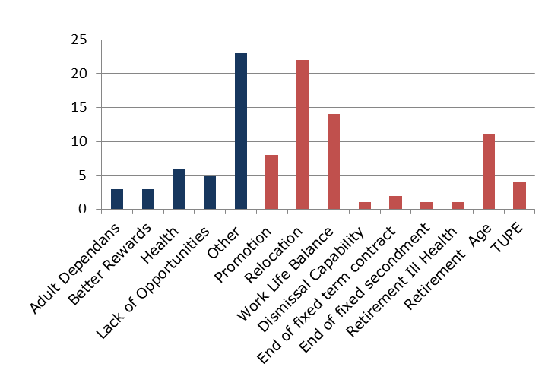

The chart above shows reasons for leaving the organisation during the year. Other/unknown 23% remains the highest. Main reasons given for leaving are relocation 22 (21%), work life balance 14 (13.3%), and retirement 11 (10.5%).

***Summary of Employee Relations Cases***

|  |  |  |  |  |  |  |  |  |
| --- | --- | --- | --- | --- | --- | --- | --- | --- |
| **Summary of Employee Relations Cases April 2017 – March 2018** | | | | | | | | |
| **Employee** | **Gender** | **Ethnic Origin** | **Disability** | **Religion/Belief** | **Marital status** | **Sexual Orientation** | **ER** | **Outcome** |
| A | Male | Black British | No | Christianity | Single | Heterosexual | Capability | Dismissal |
| B | Female | White British | No | Not disclosed | Single | Not disclosed | Grievance | TBC |
| C | Female | White British | No | Christianity | Divorced | Heterosexual | Grievance | TBC |
| D | Female | Black British | Yes | Other | Single | Heterosexual | Grievance | Appeal Stage TBC |

The sample is from April 2017 to March 2018 and due to small numbers(in the previous two years there were also 4 ER cases each year) it is difficult to draw inferences . However there are consistently 50% of ER cases involving BME staff therefore we will continue to triangulate this information with our other WRES data and agree actions to take forward.

***Gender Pay Reporting***

From April 2017 onwards, any UK organisation employing 250 or more employees is required to report publicly on its gender pay in six different ways:

1. Mean gender pay gap – ordinary pay

2. Median gender pay gap – ordinary pay

3. Mean gender pay gap – bonus pay in the 12 months ending 31 March

4. Median gender pay gap – bonus pay in the 12 months ending 31 March

5. The proportion of male and female employees paid a bonus in the 12 months ending 31 March

6. The proportion of male and female employees in each quartile

The gender pay gap shows the difference in the average earnings between all male and female employees within First Community.

The mean gender pay gap is the difference between the mean hourly rate of pay of male full-pay relevant employees and that of female full-pay relevant employees.

The median gender pay gap is the difference between the median hourly rate of pay for male full-pay relevant employees and that of female full-pay relevant employees

***Pay structure***

Majority of First Community staff, except for the Chief Executive and Director of Finance are paid on the National Agenda for Change (AfC) pay, terms and conditions system. The terms and conditions set out band structures and pay for all employees to ensure transparency, fairness and equal treatment for all.

***Profile across bands***

It should be noted that band 1 and band 9 is reflective of one employee. Similarly pay band 8d includes just 2 employees.



*With regards to bonus pay, there were no employees who received a bonus pay in the 12 months ending 31 March, as a result there are no figures for the mean or median gender bonus pay gap available.

First Community has a gender mean pay gap of 6.5% and a median gender pay gap of -1.4%, this is lower than the national figure. The Office for National Statistics reports in April 2017, that the gender pay gap based on median hourly earnings for full-time employees decreased to 9.1%, from 9.4% in 2016. This is the lowest since the survey began in 1997.

***Patient Information***

We collect equality and diversity data on our patients to help us to understand more about the people who are accessing our services and to understand what we need to do to make sure our services are accessible to everyone and meet the needs of our patients. To help us to do this we need to gather as much information as we can. We recognise there is further work to be done to improve the recording of patient data particularly with regard to ethnicity, marital status and religion and belief. The patient data represents patient numbers.

Similar to last year the gender split of patients is females 58% and males 42%.

White British remains the largest ethnic group of our patients which is reflective of our local population. Over the last two years we have seen an improvement in the recording and reporting of patient ethnicity and during 2016/2017 this had improved slightly to 64.8% of patients where we have a self reported record of their ethnicity. However this year we have 43% of patients where this is unknown and this is an area that we are working on to improve the capture of patient data.

This is the second time we have included patients’ marital status in this report and this year we have seen an improvement in the recording of marital status as the unknown figure had reduced to 57% of patients down from 73.5% last year.

0-5 years accounts for 11% of our referrals compared to 32% for over 65s.

This is the second year that we have included patients’ religion and belief in this report and we recognise that there is further work to do on reducing the figure of 75% of patients where we have not recorded this information although this has improved since last year when the figure was 84.6%.

***Public and Patient Involvement***

The Community Forum provides an on-going way to engage with, listen to and involve organisations and people in the communities where First Community provides services.

First Community held four forums in 2017-18. This year’s focus was on joining up First Community’s services with other local organisations providing health and social care services.

Community Forum meetings are open to the public, including service users, carers, volunteers, representatives from health and social care agencies, GPs, local community groups, local councils, voluntary sector organisations and local businesses.

The Chief Executive chairs the events which are held a minimum of four times a year. The membership of the forum support representation from all protected characteristic groups.

First Community was involved in developing a range of ‘prototypes’ over the year to test new ideas across a range of local health and social care needs. These were social isolation, diabetes, falls prevention, a good death and physical health of people with severe mental illness. In developing each of these prototypes, First Community worked with patients and service users, as well as health and social care specialists, to trial and test out new ways of working.

***Friends and Family test***

The Friends and family Test is a way of measuring how satisfied patients and service users are with the services that First Community provides.

The overall average over the year was 4.83 out of 5 with 95.46% saying they would be likely to recommend First Community services to friends and family if they needed similar care or treatment.

Below is a table showing First Community’s Friends and Family Test (FFT) results from 2017/18:

|  |  |  |
| --- | --- | --- |
| **Month** | **Number of responses** | **Overall FFT score out of 5** |
| April 2017 | 128 | 4.85 |
| May 2017 | 252 | 4.81 |
| June 2017 | 488 | 4.68 |
| July 2017 | 288 | 4.81 |
| August 2017 | 235 | 4.88 |
| September 2017 | 429 | 4.78 |
| October 2017 | 576 | 4.65 |
| November 2017 | 354 | 4.83 |
| December 2017 | 134 | 4.91 |
| January 2018 | 606 | 4.83 |
| February 2018 | 212 | 4.86 |
| March 2018 | 321 | 4.81 |
| **TOTAL:** | **4023** | **4.80 average for year** |

***Staff Engagement***

***Council of Governors***

The Council of Governors (CoG) is a group of representatives elected by staff to act as a link between shareholders and the Board of Directors.

Under the Articles of Association (rules of our Company): “Individual Governors of the Council are expected to promote and encourage participation by Members in the Company’s affairs”. Council of Governor representatives have a key role in shaping the organisation and promoting staff engagement to look at the strategic direction of First Community. Currently, 72% of our employees are shareholders.

***Engagement and Strategic Planning***

Staff are encouraged to engage with and shape the strategic direction of First Community.

In summer 2017, First Community CEO, held a range of group sessions and hosted informal drop ins at a range of locations to hear the views of colleagues to set First Community’s three year strategy. The resulting strategy for 2017-20 sets First Community’s direction for the next three years.

Alongside this First Community maintained its ‘floor to Board in 5 minutes’ ethos.

***Annual Awards***

To recognise excellence by individuals and teams, First Community holds an annual staff awards ceremony for all colleagues. Staff members are nominated by their peers and winners are picked by a judging panel.

The 2017 awards ceremony was held in November at Lingfield Park. Award winners came from all services within First Community. There was a special category for partners.

***Focus Groups***

CoG supported a series of focus groups within First Community to examine and plan improvements in three areas following the 2016 NHS staff survey. The three focus groups were on: Health and wellbeing of staff, corporate resources and reward and recognition. The groups made a number of recommendations in short, medium and long-term. A number of the short and medium term recommendations were implemented and the long-term suggestions are being included within strategies. Among the actions implemented were: parking permits, Walking Wednesdays, no meetings over lunchtimes and YMCA health assessments.

***NHS Staff Survey Results***

First Community participated in the NHS staff survey for a second year running to test employee engagement and satisfaction. The overall results were positive with colleagues across First Community continuing to rate its care highly, remain highly engaged and say it’s a good place to work. The latest survey took place in autumn 2017.

The results showed staff engagement increased to 4.08 (out of 5.00) compared to 4.05 in 2016. A score above 4.00 equates to a highly engaged workforce.

This puts us among the best NHS organisations for engagement in England.

Among the other highlights:

* 88% of staff said care of patients and service users is First Community’s top priority compared to 77% nationally*.
* 74% would recommend First Community as a place to work compared to 56% nationally
* 89% staff said if a friend of relative needed treatment, I would be happy with the standard of care compared to 86% last year and 78% of similar organisations.

*compared to the average for social enterprises providing community health services

The results of the 2017 survey showed some significant changes since the 2016 survey, which demonstrated differing experiences of BME (Black and Minority Ethnic) colleagues compared to white colleagues.

There was a significant fall in the number of BME colleagues who said they were discriminated against - 16% BME colleagues said they had experienced discrimination at work in 2017 compared to 29% in 2016. While this is a decrease, First Community will continue to explore this and understand what more needs to change.

In 2017, 73% BME colleagues said First Community provides equal opportunities for career progression or promotion compared to 82% in 2016. This decrease is of concern. We analysed KF20 and KF26 by the following protected characteristic groups.

|  |  |  |  |  |  |  |
| --- | --- | --- | --- | --- | --- | --- |
|  | Men | Women | Disabled | Not disabled | White | BME |
| KF20 % experiencing discrimination at work in last 12 months | 17 | 7 | 9 | 7 | 4 | 27 |
| KF26 % experiencing harassment, bullying or abuse from staff in last 12 months | 29 | 14 | 21 | 15 | 12 | 38 |
| Number of responses | 18  6% | 270  88% | 43  14% | 264  86% | 270  89% | 33  11% |

We will be taking this forward over the next year to understand these results further and to develop actions where necessary to address this inequality.

***Workforce Race Equality Standard (WRES)***

The Workforce Race Equality Standard requires organisations providing NHS services to demonstrate progress against a number of indicators of workforce equality, including a specific indicator to address the low levels of BME Board representation. It has been included in the NHS standard contract since April 2015.

We completed our initial baseline audit in 2016 and the second in July 2017. The 2017 initial results for First Community suggested variations in experiences between BME and white staff in a number of indicators. An action plan has been produced to tackle these variations. (Appendix 2).

The key actions achieved this year relating to the WRES action plan are;

* Focus groups were held with staff during October/November to discuss the findings of the NHS Staff survey and to help us to understand why BME staff feel they are being treated differently from other staff.
* The BME network has been set up and has met several times, terms of reference have been agreed.
* A data validation exercise was held in January 2018 to try to improve the staff personal equality data held on the system this has resulted in an improvement of the percentage of staff who have disclosed their ethnicity
* We have begun a Leadership Programme for Managers which will include sessions on HR and Equality Diversity and Inclusion.

***Carers Strategy 2015-2018***

In 2015 we produced a three year strategy to help us to support carers.  The strategy set out priority areas and below is updated progress;

1 Identifying and recognising carers and offering support:

* Delivered through staff training regarding carers awareness – this is an integral part of every new employee’s formal induction
* The implementation of the Surrey carers pathway and prescription including offer of a carers assessment – there have been 64 referrals using the carers prescription in the first 3 quarters of 2017/18

2 Providing information for carers

* Delivered through information on carers for staff via the internet and intranet

3 Continuing to work in partnership with other agencies

* Delivered through Surrey wide carers groups including provider and young peoples’ group working with First Community

4 Working with young carers

* Delivered through implantation of the Surrey Young Peoples’ Strategy
* First Community has signed up the Employers for Carers scheme which enables access to advice to help up support our staff who are carers.

Achievement against the objectives set out in this strategy is monitored using the Carers Strategy Action Plan. The carers lead submits a quarterly report to the Clinical Effectiveness Group to outline progress against the required objectives.

***Company Strategy 2017-2020***

First Community’s Company Strategy for 2017 – 2020 has been developed. This strategy will help us to build on our existing high standards as recognised by the CQC who rated our services overall as Outstanding in 2017 and will help us to drive forward the improvements colleagues, commissioners, partners and our community have told us they want to make. We need to work more closely with other organisations to change how health and social care services are provided locally to help us meet the needs and demands of the communities and people we serve. All of our existing policies have been developed and assessed against this?/any gaps?

***Equality Analysis***

All policies incorporate an Equality Analysis process to ensure full understanding of their potential impact on people with any of the protected characteristics, and guide action to mitigate any negative effects.

***Equality Delivery System (EDS2)***

The Equality Delivery System (EDS) originally launched in June 2011 was updated and refreshed and re-launched as the EDS2 in 2012. The main purpose of the EDS is to help organisations, in discussion with local partners including local people, review and improve their performance for people with characteristics protected by the Equality Act 2010. From April 2015 EDS2 has been a mandatory requirement within the NHS standard contract. The EDS consists of four goals:

Goal 1: Better Health Outcomes for all

Goal 2: Improved Patient Access and Experience

Goal 3: Empowered engaged and well supported staff

Goal 4: Inclusive leadership at all levels

Each goal has a number of outcomes and for each outcome there is a list of factors and these are used to assess and grade the organisation based on available evidence.

To help us to meet our public sector Equality Duty (PSED) we used the EDS2 assessment to assess and grade ourselves based on available evidence. We are grateful to Surrey Coalition of Disabled People who worked with us and provided an external assessment on how we had graded ourselves against each goal and outcome. We are pleased to report that our ratings are achieving for all goals with a recognition that in some areas work is ongoing.

We used the findings to develop our Equality Objectives:

***Equality Objectives 2015-2019***

1. To extend the workforce data that we collect, analyse and report on to ensure that we are meeting the requirements of the Equality Act 2010. To prepare for the introduction of the Workforce Race Equality Standard and the requirement to demonstrate progress against a number of indicators of workforce equality, including a specific indicator to address the low levels of BME staff at senior levels and Board representation.

2. To continue to improve on the collection of patient’s ethnicity data and to set a target of 80% for all services with regard the reporting of ethnicity. To then review how we can build on this to include other ethnicity data such as religion and belief etc To support staff to know and understand the community who access services ensuring that staff understand the equality priorities for the organisation, and have access to information about the protected characteristic groups, their health needs and the challenges that these groups face.

3. To develop the EDS2 further working with our community partners to grade and assess the organisation against the 4 goals as set out in the NHS standard contract from April 2015.

4. To review how the organisation communicates and engages with all of the protected characteristic groups in our community, to ensure that all have the opportunity to be involved and engaged with us.

Although we still have a year to run on the Equality Objectives they have been mostly completed. We will develop new Equality Objectives from 2018 onwards ensuring that Objective 2 is carried forward to help us improve our collection of patient ethnicity data.

***Complaints***

Complaints Received: First Community Health and Care received a total of 31 complaints from 1st April 2017 until 31st March 2018. These complaints relate directly to services provided by First Community and one complaint was a joint response with South East Coast Ambulance Foundation Trust (SECAmb). Complaints were received across both adult and children’s services.

The breakdown of the figures shows that 55% (17) of the complaints concerned female patients and 45% (14) related to male patients.

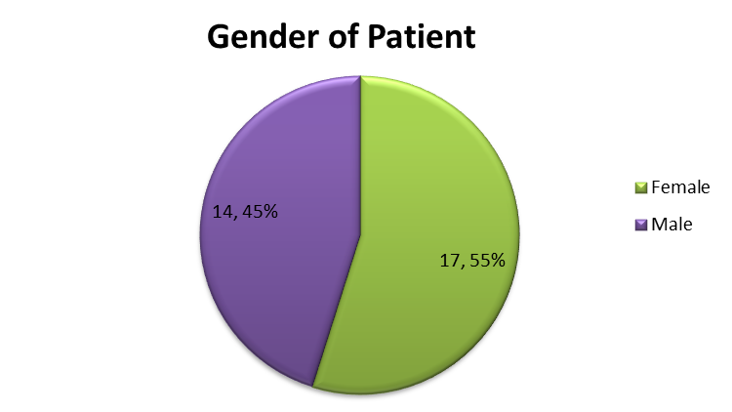

The ethnicity breakdown shows that 74% (23) of the patients were White British,16% (5) were of unknown ethnicity, 3% (1) Caribbean, 3% (1) Other White and Not Given 3%(1). Information has been gathered from Emis (the patient administration system) but ethnicity is not captured for all patients.

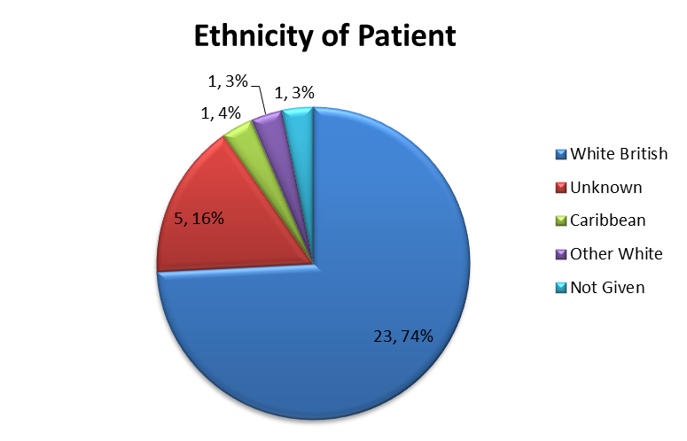

The age of the patient concerned in the complaint is not asked for, but this information can also be obtained from Emis, however two patients do not have an Emis record and their age is therefore not known. The data shows that 7% (2) of the complaints received relate to patients over 89, 16% (5) relate to patients aged 79-88, 13% (4) relate to patients aged 69-78, 13% (4) relate to patients aged 59-68, 13% (4) relate to patients between 49-58, 13% (4) relate to patients 39-48, 7% (2) relate to patients 29-38, 3%(1) to patients aged 19-28, 7%(2) relate to patients 9-18, 3% (1) relate to patients 0-9 and 7%(2) where the ages of the patients are unknown.

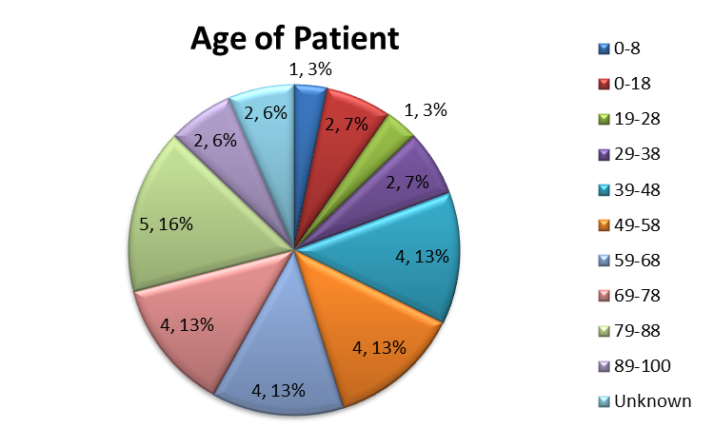

***Accessible Information Standard (AIS)***

This new standard was developed by NHS England in order to address the current disparity in the care received by disabled people. It aim is to ensure that information from Adult social care and NHS providers is provided to all service users and patients in a way they can understand. We implemented the AIS standard by 31st July.

It is of particular relevance to individuals who are visually impaired hearing impaired or who have a learning disability, although it will support anyone with information or communication needs relating to a disability, impairment or sensory loss, for example people who have aphasia or a mental health condition which affects their ability to communicate.

There are five basic steps which make up the Accessible Information Standard:

1. Ask: identify / find out if an individual has any communication / information needs relating to a disability or sensory loss and if so what they are.

2. Record: record those needs in a clear, unambiguous and standardised way in electronic and / or paper based record / administrative systems / documents.

3. Alert / flag / highlight: ensure that recorded needs are ‘highly visible’ whenever the individual’s record is accessed, and prompt for action.

4. Share: include information about individuals’ information / communication needs as part of existing data sharing processes (and in line with existing information governance frameworks).

5. Act: take steps to ensure that individuals receive information which they can access and understand, and receive communication support if they need it.

We reviewed our patient recording systems both paper and IT, ensured staff are trained in how to action the five steps of the standard and have raised awareness with patients that we will be asking this question and acting upon what they tell us. We have developed policies and guidance for staff, posters for patients and included information on our website about the AIS. We are working with our local voluntary sector colleagues to review and audit how the standard is working and the impact it has on patients. Quarterly reports are produced as part of the Quality Account that looks at how many patients are referred in, how many of those are actually being asked if they have an additional communication need (as per the AIS guidance), of those who are asked how many actually have a need and if they do what that need is. Appendix 1 shows the data for April 2017 to March 2018 and the type of assistance required.

The majority of patients who need communication assistance are;

Requires contact via carer total for year 120

Does use hearing aid total for year 97

Needs an advocate total for year 95

Requires written information in at least 20 point total for year 66

***Equality, Diversity and Human Rights training***

According to our Statutory and Mandatory Training Matrix, all staff – including both substantive and Bank staff - must complete Equality, Diversity training within six months of commencing in the organisation and complete a refresher every three years. A blended approach to training is provided giving staff the option to complete eLearning modules or to attend a face to face session.

Training compliance reports have been run fortnightly until July and then monthly. Along with the compliance report, exception reports have been produced concurrently identifying staff who are non-compliant, the reports are circulated to all service leads to disseminate and follow up with each staff member.

For 2017/18 our compliance target was increased from 80% to 85% and our plan moving forward will be to increase our compliance targets in annual 5% increments up to 95%.

The report clearly demonstrates a drop in compliance and we have been able to identify that a contributing factor relates to issues with the reports run from the LMS and, in particular, the eLearning modules. The eLearning content for equality and diversity includes 16 separate modules – 8 reading and 8 assessments - Some staff members – who have not completed all the modules - have been identified as being compliant. We have produced an action plan to resolve this which is involves rebuilding the reports and is currently in progress.



***Priorities for the next 12 months***

* To update and refresh EDS2 to inform development new equality objectives for the organisation
* To improve the quality of the patient data we collect
* To continue to implement the WRES action plan to help us reduce the variation in experiences between BME and white staff
* To prepare for the introduction of the Workforce Disability Equality standard

Appendix 1

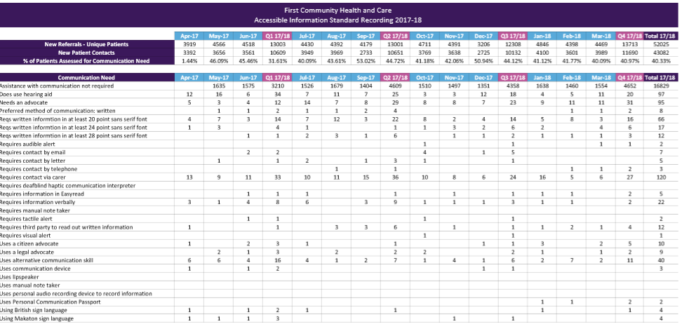

Appendix 2 **WRES Action plan v8**

|  |  |
| --- | --- |
| **Project title** | WRES Data |
| **Project lead** | Tina Gull |

|  |  |  |
| --- | --- | --- |
| **Action plan lead** | Name: Tina Gull | Title: Equality and Diversity Specialist |

Ensure that the recommendations detailed in the action plan mirror those recorded in the “Recommendations” section of the report. The “Actions required” should specifically state what needs to be done to achieve the recommendation. All updates to the action plan should be included in the “Comments” section.

| **#** | **Recommendation** | **Actions required** *(specify “None”, if none required)* | **Action by date** | **Person responsible** | **Comments/action status** | **Change stage** |
| --- | --- | --- | --- | --- | --- | --- |
| 1 | Increase the proportion of total staff who have self–reported their ethnicity | * 1. Produce a letter / personal data audit from Chief Executive to all staff members for data validation by end of August 2017   2. Agree process & timeline, then circulate to WRES group   3. All staff to return the letter with updated details   4. Annual data validation for all staff to be verified by senior managers | December 2017 | Angelique Humphris/  Jenny Rawlinson | Personal data audit now complete – deadline was 5 January. 239 responses have been received out of 521. Reminder communication will be going out to staff by Thursday 11 January, to try increase return rate. | 3 |
| 2 | Ensure correct data is available from data system to   * Calculate the relative likelihood of staff being appointed from shortlisting across all posts. * Coding of clinical and non- clinical roles | * 1. Transition HR delivery to be managed by First Community   2. Utilising full functionality of nhs jobs to ensure data is captured   3. HR team, will be responsible for producing this data   4. Ensure the occupational codes in the current system are correct against existing posts | ~~January 2018~~  May 2018 | Angelique Humphris | March Senior Team Meeting - share update  March 2018 – Transition in progress, review of data in progress for WRES submission – completion data extended to May 2018 |  |
| 3 | Achieve no difference in relative likelihood of being appointed to an FC position between BME and white staff | * 1. A consistent selection process for interviews   2. Produce managers training programme and process to include      + awareness of unconscious bias      + reverse mentoring interviewing,      + rationale for selection,      + consistency for documentation and records keeping and equal opportunities | April 2019 | Angelique Humphris | Safer Recruitment Training given to all staff who recruit and staff aren’t allowed to recruit without completion of this training which includes all of action 3.2. Recruitment undertaken via NHS Jobs |  |
| 4 | Achieve no difference in the relative likelihood of entering the formal disciplinary process between BME and white staff | 4.1 Establish a focus group for BME to listen to staff concerns   * 1. Use feedback from focus group to inform actions   2. To review employee relations (ER) cases at part 2 of WEG share consider discussing themes & areas of concern from -AH   3. Produce managers training programme on and process to include   + awareness of unconscious bias   + reverse mentoring   + managing competency and conduct issues in a timely fashion | April 2019 | Denise Thiruchelvam/ Tina Gull  Angelique Humphris/ Mel Dawson | BME group has been set up and meets quarterly and feedback will be used to inform next WRES action plan.  4.3 Workforce dashboard being developed to triangulate workforce themes and this is in workforce strategy action plan  Leadership training has been developed and is part of annual training programme for staff and includes the areas in action 4.4 | 3 |
| 5 | Achieve no difference in the relative likelihood staff accessing non-mandatory training and CPD between BME and white staff | * 1. Review staff survey results and identify if there is variation between services   2. Monitoring the E&D status from the educational data | August 2018 | Mel Dawson/ Alison Maitland | To include care certification |  |
| 6 | To reduce the percentage of staff who experience harassment, bulling or abuse from patients, relative or the public in the last 12 months. | * 1. To discuss with Inge (TIA) and ask if there are any case studies- to review the national examples to reduce harassment at work   2. Use a variety of communications incl CoG regarding an approach to tackling this variation & if % acceptable   3. Get right messages out to staff to prevent this | January 2018 | Amjad Nazir/ Angelique Humphris/ Jenny Rawlinson | Self assess against best practice |  |
| 7 | Achieve no difference in the percentage of staff experiencing harassment, bullying or abuse from staff in last 12 months between BME and white staff | * 1. Establish a focus group for BME to listen to staff concerns- 18 October 2017   2. Review L&D training   + E&D   + Conflict resolution training.   + Manager programme   1. Review staff survey results and identify if there is variation between services.   2. Roll out of above training, using a targeted approach | April 2019 | Angelique Humphris/ Mel Dawson |  |  |
| 8 | Achieve no statistically significant percentage difference between BME and white staff believing that trust provides equal opportunities for career progression or promotion | 8.1 Establish a focus group for BME to listen to staff concerns - 18 October 2017   * 1. Review staff survey results and identify if there is variation between services | August 2018 | Angelique Humphris/ Mel Dawson | BME group set up and meeting quarterly |  |
| 9 | Achieve no percentage difference between BME and white staff personally experiencing discrimination at work from manager/team leader or other colleagues | * 1. Establish a focus group for BME to listen to staff concerns   2. Review staff survey results and identify if there is variation between services | August 2018 | Denise Thiruchelvam/ Tina Gull | BME group set up and meeting quarterly |  |
| 10 | The boards are expected to be broadly representative of the population they serve | 10.1 Board to evidence recruitment procedure   * 1. The board to ensure there is equal opportunity of accessing recruitment   2. Consider use of national recruitment sites e.g. NHS Jobs and   <https://publicappointments.cabinetoffice.gov.uk/nhs-appointments/> | August 2018 | Elaine Best & CoG/ HR |  |  |